ASTA 607_22425133

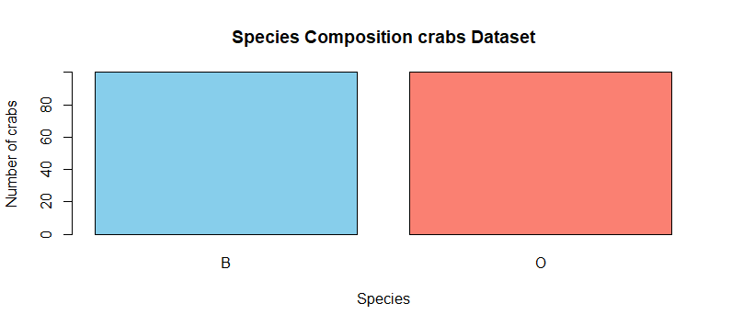
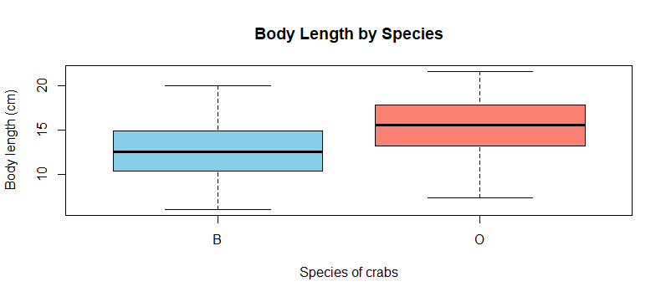
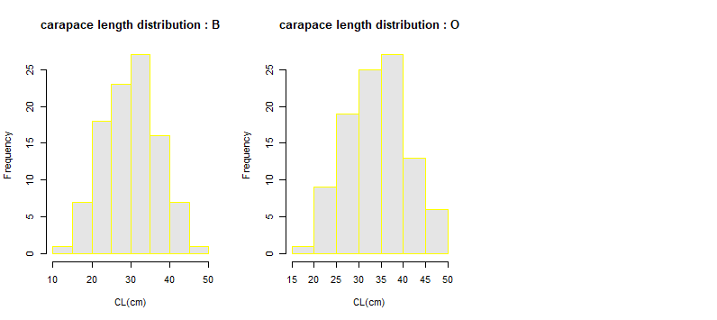

data.frame': 200 obs. of 8 variables:
$ sp : Factor w/ 2 levels "B","O": 1 1 1 1 1 1 1 1 1 1 ...
$ sex : Factor w/ 2 levels "F","M": 2 2 2 2 2 2 2 2 2 2 ...
$ index: int 1 2 3 4 5 6 7 8 9 10 ...
$ FL : num 8.1 8.8 9.2 9.6 9.8 10.8 11.1 11.6 11.8 11.8 ...
$ RW : num 6.7 7.7 7.8 7.9 8 9 9.9 9.1 9.6 10.5 ...
$ CL : num 16.1 18.1 19 20.1 20.3 23 23.8 24.5 24.2 25.2 ...
$ CW : num 19 20.8 22.4 23.1 23 26.5 27.1 28.4 27.8 29.3 ...
$ BD : num 7 7.4 7.7 8.2 8.2 9.8 9.8 10.4 9.7 10.3 ...
> dim(crabs)
[1] 200 8
> sapply(crabs,class)
sp sex index FL RW CL CW BD
"factor" "factor" "integer" "numeric" "numeric" "numeric" "numeric" "numeric"

INTEGRATED STATISTICAL REPORT
####################################
# a) data set in Mass
library(MASS )
# b) data structure
data(crabs)
str(crabs)
dim(crabs)
sapply(crabs,class)

# c) frequency tables for species and sex
freq_tbl <- table(crabs$sp)
freq_tbl
as.data.frame(freq_tbl)

###(d) Bar chart (qualitative display)
barplot(freq_tbl,
main = "Species Composition crabs Dataset",
xlab = "Species",
ylab = "Number of crabs",
col = c("skyblue", "salmon"))

### e) the data set is balanced accrosss all the groups
freq_tbl
prop.table(freq_tbl)

## a) boxplot
boxplot(BD ~ sp, data = crabs,
main = "Body Length by Species",
xlab = "Species of crabs",
ylab = "Body length (cm)",
col = c("skyblue", "salmon"))

##### b) Group B and O both have outliers but that of O is
### more profound.

###### 3.Carapace length distribution by species
?hist
par(mfrow = c(1, 3))

for (sp in levels(crabs$sp)) {
x <- crabs$CL[crabs$sp == sp]
hist(x,
main = paste("carapace length distribution :",sp),
xlab = "CL(cm)",
ylab = "Frequency",
col = "gray90",
border = "yellow")
}

par(mfrow = c(1, 1))
border = "yellow"

### b) Both are unimodal and approximately normal

######### comparison of means

get_mode <- function(x) {
ux <- unique(x)
tab <- tabulate(match(x, ux))
ux[tab == max(tab)]
}
## summary table
# Overall
overall <- data.frame(
Group = "Overall",
Mean = mean(crabs$FL),
Median = median(crabs$FL),
Mode = paste(get_mode(crabs$FL), collapse = ", ")
)

# By species

by_sp <- do.call(rbind, lapply(split(crabs, crabs$Species), function(d) {
data.frame(
Group = as.character(sp$sp[1]),
Mean = mean(sp$FL),
Median = median(sp$CL),
Mode = paste(get_mode(sp$BD), collapse = ", ")
)
}))

q2_table <- rbind(overall, by_sp)

